Rockland Minor Hockey Association (RMHA)
Discipline Policy

Rockland Minor Hockey Association (RMHA)
  - Discipline Policy & Complaint Pathway
Version: December – 2025

Table of Contents
1. Purpose & Principles
2. Special Cases (Police Involvement)
3. Scope
4. Reporting Process
5. Levels of Misconduct & Sanctions
6. Discipline Committee Structure
7. RMHA Timeline & Cost
8. Appeals Process
9. Repeat Offenders & Multi-Year Actions
10. Constitutional Alignment
11. Review & Amendments
Appendix A: RMHA Discipline Flowchart
Appendix B: RMHA Complaint Form
Appendix C: Spectator/Parent Code of Conduct
Appendix D: Player Code of Conduct
Appendix E: Coach/Bench Staff Code of Conduct

1. Purpose & Principles
The RMHA Discipline Policy exists to foster a safe, respectful, and fair hockey environment. It aligns with the Hockey Canada Code of Conduct, Hockey Eastern Ontario (HEO), District 3 regulations, and the RMHA Constitution. Discipline is progressive, fair, and transparent. Any incident that is potentially criminal is to be referred immediately to external authorities.

2. Special Cases (Police Involvement)
Any potentially criminal allegation (e.g., sexual assault, abuse, higher-level harassment) is to be immediately reported to Police or appropriate external authorities while at the same time, the individual is to inform the appropriate RMHA Vice-President (VP) of contact with authorities.

3. Scope
This policy applies to all members of RMHA including players, parents, guardians, coaches, team officials, spectators, Executive Board members, and volunteers.

4. Reporting Process
• Step 1: All non-criminal incidents must observe a 24-hour cooling period.
• Step 2: Team-level resolution is expected first. When discussions do not resolve an issue, formal written complaints are filed with the appropriate person – be it Head Coach/Team Manager or if Association is needed, the appropriate RMHA Vice-President (VP).
• Step 3: If unresolved or more complex, the complaint is escalated to the appropriate RMHA Vice-President (VP).
• Step 4: The RMHA VP reviews the matter and determines if it should proceed to a Discipline Committee.
• Step 5: The RMHA VP may decide to provide a resolution on their own or have a resolution provided by a Discipline Committee. Any consequence or sanction would be provided at this time.

5. Levels of Misconduct & Sanctions

This section establishes the framework for classifying misconduct and determining appropriate disciplinary measures. It ensures consistency, fairness, and transparency in addressing violations of organizational standards.
The severity of misconduct may vary based on:
- Repetition of the behavior
- Intent and effort (e.g., deliberate vs. accidental)
- Impact on individuals, teams, or organizational integrity
Misconduct is classified into four levels:
- Minor
Low-impact infractions, typically isolated and unintentional.
Examples:
  - Occasional tardiness
  - Inappropriate language
  - Minor Insubordination
- Moderate
Repeated or deliberate actions causing disruption or harm.
Examples:
  - Disrespect to Officials
  - Unsportsmanlike conduct
  - Harassment
- Severe
Significant violations with clear negative impact on safety or operations.
Examples:
  - Harassment, Fighting and/or bullying
  - Substance use during official activities
  - Threatening behavior
  - Discrimination
- Potentially Criminal
Actions that may violate laws and require legal intervention.
Examples:
  - Physical assault
  - Theft or fraud
  - Vandalism
- Repeated Minor Infractions may escalate to Moderate Misconduct if they occur frequently or after prior warnings.
- Moderate Misconduct that continues despite corrective action may be treated as Severe Misconduct.
- Severe Misconduct may result in immediate suspension or expulsion
- Potentially Criminal Acts require immediate reporting to law enforcement and may result in permanent removal from the association.
Disciplinary measures will be proportionate to the severity and circumstances of the misconduct. Possible actions include:
- Verbal warning
- Written reprimand
- Single-game suspension
- Multiple-game suspension
- Probation
- Season or multi-season ban
- Expulsion from the organization
- Immediate notification to law enforcement

Mandatory Anti-Bullying Education
An anti-bullying education session is expected to be conducted at the start of each season for all players in the U13 to U18 age divisions. Attendance at this session is mandatory for all participants. This session is could be led by the district or an executive of the association.
Failure to attend will result in suspension from all team-related activities, both on and off the ice, until the player completes the required session.
This session will also serve as the player’s first formal warning regarding bullying-related behavior.
The RMHA Executive individual responsible for Risk and Safety (or the President) will take all necessary steps to ensure that sessions are scheduled at a time and location that is reasonable and accessible for all members of the association.

6. Discipline Committee Structure
A Discipline Committee, if determined to be necessary, will be formed by the President and comprise of an odd-number of individuals and would be composed of:
- appropriate RMHA Vice President (Chair)
- RMHA Risk & Safety Officer
- appropriate Board Member(s)
- all efforts will be made to avoid potential conflicts of interest when selecting individuals

The President (not counted in the “odd-number” above) may or may not choose to attend and may be included in discussion but will not be able to cast a vote if a vote is needed.

7. RMHA Timelines & Cost
With the goal of resolving issues promptly and avoiding unnecessary delays, a “72-hour concept” will be followed by RMHA whenever possible. Certain factors—such as availability of individuals or meeting rooms, weather, or delays in gathering information—may occasionally prevent this timeframe from being met. When feasible, the 72-hour window will apply in the following way;
- an incident is to be reported within 72-hours of its occurrence (keeping in mind the 24-hour Rule before reporting however)
- some form of response can be expected within 72-hours of the time the incident is reported. Responses within this timeframe may include
- Team-level conclusion
- Team-level requires more time to gather details before a conclusion can be given
- Appropriate RMHA VP conclusion
- RMHA VP requires more time to gather details before a conclusion can be given
- An RMHA Discipline Committee will be formed
(Note that any response provided within this timeframe may not be final and should not be seen to limit any other further future actions.)

- where more time is needed to gather details, it is expected, where circumstances allow, a conclusion would be reached within a subsequent 72-hour timeframe.

- where a Discipline Committee is determined necessary, it is to be, where circumstances allow, convened within 72-hours

- once a Discipline Committee has convened, it is expected to provide a written response within 72-hours

RMHA requires no payment from a Complainant in order to process a complaint, even where a Discipline Committee is involved.

8. Appeals Process
Decisions may be appealed outside of RMHA first to District 3, then to HEO, and ultimately to Hockey Canada. Appeals must be filed in writing within defined timelines and any monies paid as necessary. Any timing limitations and/or any fees to be paid are the responsibility of the appellant.

9. Repeat Offenders & Multi-Year Actions
RMHA recognizes the importance of addressing repeat misconduct and ensuring accountability across multiple seasons. To this end, the following rules apply:
1. Carry-Over Sanctions:
- Any suspension or disciplinary action not completed in one season will carry forward into the following season.
- Members are not considered 'in good standing' until sanctions are fully served.
2. Repeat Offenders:
- Members (players, parents, coaches, spectators) who commit the same or similar offense in multiple seasons will face progressive sanctions beyond the standard first-offense penalties.
3. Alignment with Hockey Canada / HEO / District 3:
- Hockey Canada Rule Book (Section 11) and HEO Regulations permit progressive discipline and require associations to track misconduct across seasons.
- District 3 expects associations to enforce carry-over sanctions to maintain accountability.

10. Constitutional Alignment
This policy is consistent with the RMHA Constitution, which gives the Executive and Discipline Committee authority to suspend or expel members.

11. Review & Amendments
This policy shall be reviewed annually or as required by the RMHA Executive. In the absence of any overriding clause, amendments to this policy must be presented to the sitting Executive Board and be approved at a regular monthly Executive meeting.

Appendix A - RMHA Discipline Flowchart
The following chart summarizes the discipline reporting and escalation pathway:
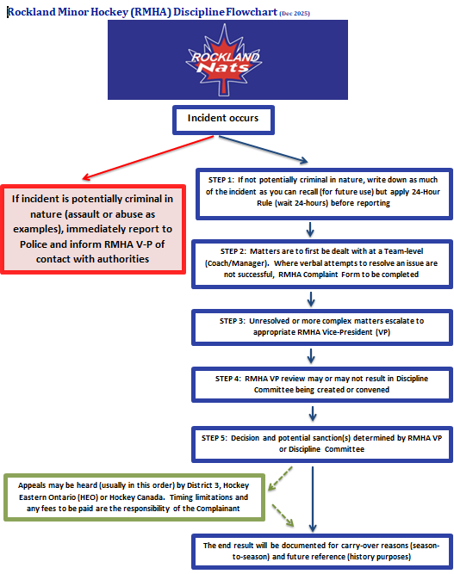

Appendix B - RMHA Complaint Form

This section to be added when live on website with link to google form

Appendix C – Spectator/Parent Code of Conduct

Link to form on website

Appendix D – Player Code of Conduct

Link to form on website

Appendix E – Coach/Bench Staff Code of Conduct

Link to form on website

